Assignment 1.2.9 Debriefing

# What’s This About?

Many of you have said that the CSS assignment was difficult, especially since we didn’t have a lot of time to cover it in class. I wanted to put this document together to help go through the in-class “student bio” exercise.

## The Assignment

The assignment covered here is 1.2.9, where you’re asked to create this:

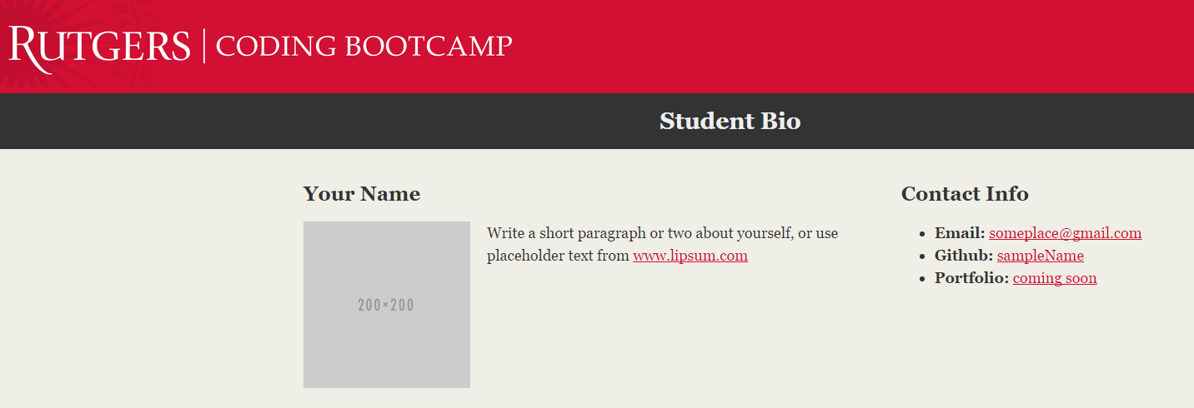

## First Things First – The HTML “Scaffolding”

Before we do anything else, let’s make the basic HTML page. This will be made up of:

1. The DOCTYPE, which tells a browser tying to display the page what version of HTML the page is made up of.
2. The <html> and </html> tags, which will contain all other tags in the document.
3. The <head> and </head> tags, which will contain things like the page title and any files (such as stylesheets) which should be included.
4. The <body> and </body> tags, which contain the “meat” of the page. This is where the things you want to display on the page will be found.

See the picture on the next page for the scaffolding to use.

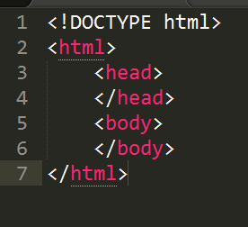

Add the <title> tag in the <head> section. Call it whatever you like

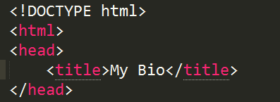

## Adding a Style Sheet

Since this page will be using CSS to style itself, we’ll need to create a stylesheet. Then we’ll need to tell the page where to find the style sheet.

To make this a much like a “real” page as possible, let’s make a folder in the same directory as our bio HTML page. We’ll call it “assets” since it will hold stylesheets, images, and whatever else might be needed to help the page do its thing.

Once you’ve created the folder, do a quick “ls –l” or “ls –la” to see that the “assets” folder is there. Be sure that the “assets” folder is in the same folder as the HTML page containing your bio.

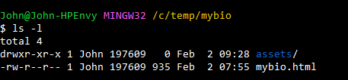

Go into the “css” folder and create the stylesheet. Call it “styles.css”. You don’t need to add anything to it just yet, just make sure it’s created.

Now we’ll go back to the HTML page and make sure the page can “see” the stylesheet. To do this, we’ll use a <link> tag. A <link> tag is one way to “refer” to a document from inside an HTML document. This allows us to break up a project into smaller pieces rather than putting everything into the HTML document.

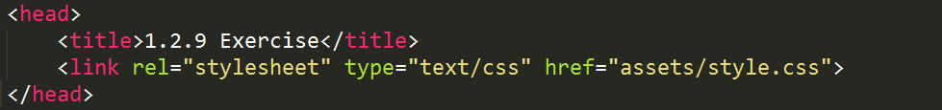

Notice that the <link> tag has a few items inside of it, but we’re interested in the “href”. That’s what we use to tell the HTML page where to find the stylesheet. The “href=’assets/style.css” says to the page “There’s a file called “styles.css” in the folder called “assets”. Please load it up and use what’s inside.

## The Good Parts

Now, let’s get started on the items we’re supposed to display. These items will all be within the <body> section.

## The Header

The first thing to do is create the page’s header. That’s going to be the Rutgers image and the title “Student Bio”.

We can do this a few different ways, but the smartest way is to use a <header> tag. You could use a plain-old <div> tag, but <headers> are good for things like this because they tell things like search engines what the header of the page is. Note that the <header> tag has nothing to do with the <head> tag.

We’re supposed to use the “RutgersBanner.png” image which was supplied to us. That should be put in the “assets” folder. Then we can place it in the document using an <img> tag. After that, use an <h1> tag for the “Student Bio” headline.

